Disclaimer: The content provided in this blog is for informational and educational purposes only and does not constitute financial, investment, or legal advice. I am not a registered investment advisor, and nothing herein should be construed as personalized recommendations to buy, sell, or hold any security. All investments involve risk, including the potential loss of principal, and past performance is not indicative of future results. I may hold positions in securities discussed, and my opinions are based on my own research and experiences. Always conduct your own due diligence and consult with a qualified financial professional before making any investment decisions. I assume no liability for any actions taken based on this information.

Blog 1 - Introduction
What is the point of this blog?
To educate my readers about financial markets, value investing, give stock picks and track my own portfolio over time.
What do I believe in? What is my strategy? Why do I believe in this strategy? What evidence backs this? What will future blog posts be about?
I aim to answer all these questions and more in this blog post with a deep discussion of the research, data, and different opinions out there in this counter-intuitive world of investing.

What Do I believe?
Price & quality > hype.
“most investors typically don't take into consideration market pricing. In other words, they tend to identify what has been a great investment (e.g., a strongly performing company) as great, and they don't pay enough attention to its pricing, even though its pricing (whether it is cheap or expensive) is the most important thing.” – Ray Dalio
Most of what I believe and what these blog posts will be about can be summarized by the above quote. Through all my subjective experiences, education from different fields, experience investing in the market, and learning from those far wiser than I, I have seen that over time, buying great companies at a great price is the lowest risk but also highest return strategy of investing in the market. This is partially how Warren Buffet has returned 19.9% annually from 1965-2024, compared with the S&P 500’s 10.4%. Warren Buffet’s focus is more on buying “great businesses at a fair price,” but early on he was influenced heavily by value investors like Benjamin Graham, and value investors today prove the outsized return potential still exists.
And yet I’m sure you have rarely heard of this. What we mainly hear about is the next AI stock bound to make you a millionaire, the next quantum-computing penny stock to create generational wealth, the hottest crypto meme coin, or the fund that has 60 physics PhDs and 100 computer science quants running high frequency trading strategies.
Why? How have investors like Warren Buffet and Benjamin Graham created such phenomenal returns compared to the market?
First, I think it would be helpful to detail the breakdown of the US stock market across investor categories. Below is a breakdown as of June 2025.
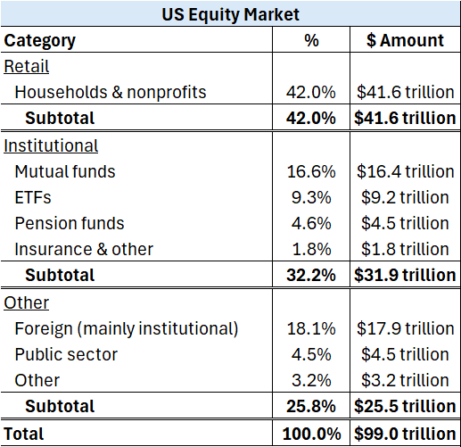
Table 2: US equity market by investor category (Q2 2025)
Note, the retail portion of the market (42%) includes financial advisors that have discretion over client funds and choose to stock pick themselves rather than invest in managed funds or ETFs. So the truly self-directed portion is lower, although no great estimates exist.
The picture is clear. Majority of the money in global and US equity markets is professionally managed, either by financial advisors, large institutional funds, or foreign investors. A minority is truly self-directed.
With this background, we can now answer these questions better. Why are speculative growth stocks what we mainly hear about? How have Buffet and Graham created such phenomenal returns compared to the market?

The Strategy
So how do we take advantage of these biases and mispricings?
The strategy is referred to as “value investing,” although with a simultaneous on quality companies, not just value for values sake. The goal is to buy super strong companies at a very attractive price. Companies that have strong balance sheets, generate lots of cash, have a defensible business, and are going to continue to grow over time, but have been beaten down in the stock market due to short-term bad news, general market downturns, recent poor performance, or a variety of other reasons.
Although extremely hard to determine what it is, every company has a theoretical “intrinsic value” which should be equal to the discounted series of cash flows an investor will receive from that investment. In theory, this is what the stock price should be. The problem is that no one can precisely estimate this, although some will try, so other factors start to determine the stock price. These factors are usually news and sentiment driven and have little or nothing to do with financial or business reasons. So, stock prices change every day for reasons unrelated to the core business and financial standing of the company, creating opportunities to buy great companies at an even better price.
Let’s imagine you have a friend, Bob. Bob, let’s say, is always in need of cash and because you frequently have $50 bills and hate going to the bank, you are happy to give him cash in exchange for a Venmo payment. However, Bob tends to exaggerate things, cares too much about what others think, and is extremely irrational. So, every day, for reasons you and Bob can’t fully explain, he buys these $50 bills for a different amount. One day he comes over in a panic and gives you $80 for the $50 bill, saying there’s a shortage of them and how valuable they’re going to be. Other days, he says your $50 bill is only worth $20 and can’t give you anymore for it, citing a variety of reasons why.
Then, what if I told you that Bob is the stock market, and your $50 bill is a stock. This happens every day. I mean really, think about it. Apple stock can swing up 5% in a day, and down 10% the next day, for no reason other than what others think it’s worth, regardless of the actual financial situation. Apple has been around since 1976, did $416 billion in revenue in 2025, and has $55 billion in cash. Do you really think their financial situation changed by a matter of 5% and then 10% over the course of 2 days? Absolutely not.
This is what quality value investing is. Buying a super solid company at a very attractive price, because the market thinks it isn’t worth that much, despite strong financial security, future growth prospects, and a great management team in an industry that’s not going away. And when the market thinks it’s worth way more than it actually is, selling it back to Bob and looking for the next opportunity. This is how Warren Buffet and other value investors have made billions.
So, the skill is not in being a quantitative wizard and financial genius, but in independent reason, discipline, and patience. It becomes more a game of art and wisdom combined with financial and business knowledge, not just pure statistics and forecasting.

What Does The Data Say About Value Investing?
By the name alone, value investing is subjective. It depends on what you define as “value.” Many investors have had different metrics to determine “value,” and many have had great success. So, there isn’t a singular data point to look at and say whether it has been a successful strategy. But we can look at a few data points to get a sense of how the general principle performed in the past.
Economists Eugene Fama and Kenneth French set out to answer the same question back in 1992, and their work is continued into today. They define value as stocks with a high book to market ratio (book value equity/market capitalization), where book value is total assets – total liabilities. Said differently, companies whose valuation in the market is cheap compared to their net assets.
After accounting for general market returns, risk, and company size, this “value” factor outperformed the market by 4.2% annualized from 1926 – 2025. Although consistent over the long term, value is cyclical and underperforms in periods of high growth and positive sentiment. From 2007-2020, this “value” factor underperformed the market by 3.5% annually and has underperformed by 2.36% over the last 12 months, as focus is on the future of AI and growth potential.
Immediately jumping to the conclusion that this “value” is a better investment is overly simplistic though and doesn’t consider why these companies are trading at relatively undervalued book to market ratios. It could be that they are inexpensive because they are seen as riskier to investors, pushing the price down (and thus the book to market ratio up). And because they are riskier, in an efficient market they will earn higher returns to compensate for this increased risk, explaining the excess returns. In other words, these “value” stocks earn higher returns simply because they are riskier, and this risk is why the book to market ratio is more favorable. This is the view Fama and French take themselves.
Behavioral economist Richard Thaler disagrees with their interpretation though and argues that value is the result of overreactions by investors and other behavioral biases. Because of these biases, investors chase hype/growth and neglect value, seeing only the recent bad news that created the value purchase. Likewise, they overweight the recent great news and performance of the growth stocks.
Testing the theory, a 2015 paper by Thaler finds behavioral models explained 50-70% of the returns from Fama and French’s “value” factor above, through investor preferences that lead to systematic mispricing, rather than purely rational risk compensation. They attribute this to prospect theory, the bias that investors are more sensitive to losing money than to earning the same amount of money.
Likely, the answer is somewhere in the middle. Yes, “value” stocks measured with book to market ratios outperform the general market over the long term. Some of this outperformance is attributed to higher risk which demands higher returns, aligning with efficient markets. But some of this outperformance is attributed to behavioral gaps and mean reversion creating systematic mispricing leading to investment opportunities.
How does this work in practice?
Value stocks/opportunities follow bad news or poor performance, putting them in the loss domain or associating the stock as a loser. Due to loss aversion, investors anchor on this poor past performance and are reluctant to fully incorporate positive signals (great fundamentals or future growth opportunities). Investors also irrationally forecast this poor performance out indefinitely. This underreaction and irrational forecast keeps prices depressed longer than rational models predict, leading to higher future returns as the mispricing corrects. In contrast, growth stocks (hype) benefit from overreaction to positive signals, inflating prices temporarily.
Ironically, buying the poorly performing stock at a great price is safer than buying the highly profitable and quickly growing stock at full price, for two main reasons.
First is what was just discussed, i.e., the behavioral biases. The growth stock’s future performance is already “priced in,” meaning today’s stock price already reflects this optimistic forecast. The company might perform in line with expectations, but if it doesn’t, returns will likely underperform the market. On the other hand, because of these biases, the value stock’s price reflects continued poor performance, even if future catalysts and financial metrics indicate otherwise. So, if the value company performs better than is (irrationally) expected, you benefit from both a repricing of the stock to a higher valuation more in line with the market, and from the earnings growth of the underlying company.
This brings into play the second reason buying the value stock is often safer than the growth stock with positive recent performance: mean reversion. Counterintuitively, the growth stock with great profitability and high growth is more likely to face increased competition as competitors enter the market, reducing sales growth and profit margins. Meanwhile, the recent underperformance of the value stock is likely to see a turnaround as the company adapts and plots a turnaround.
Let’s visualize this. Let’s imagine a growth company VS a value company. The growth company grows earnings quickly in the beginning, and then stabilizes, totaling 97% EPS growth over 36 months, while the value company has negative EPS growth, then stabilizes earnings and slowly grows them totaling 20% EPS growth.
Also happening over time, markets are revaluing both stocks to reflect investors’ new predictions about the future. The growth stock’s P/E ratio comes down as investors realize new entrants are joining the market and growth is slowing, demanding a better price. On the other hand, the value stock’s earnings have started to grow again, and the company has proven a turnaround, leading to more optimism and a higher valuation.
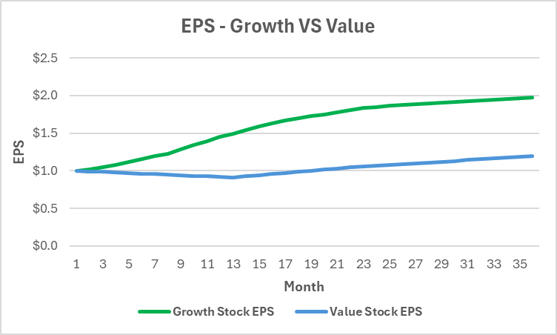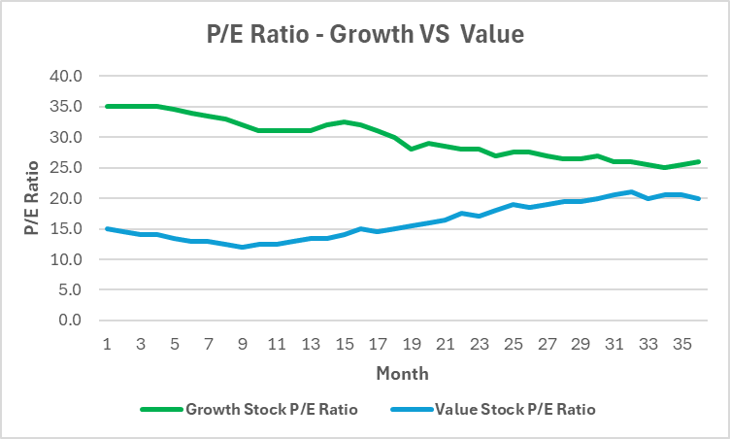
What does this do to stock prices and total returns?
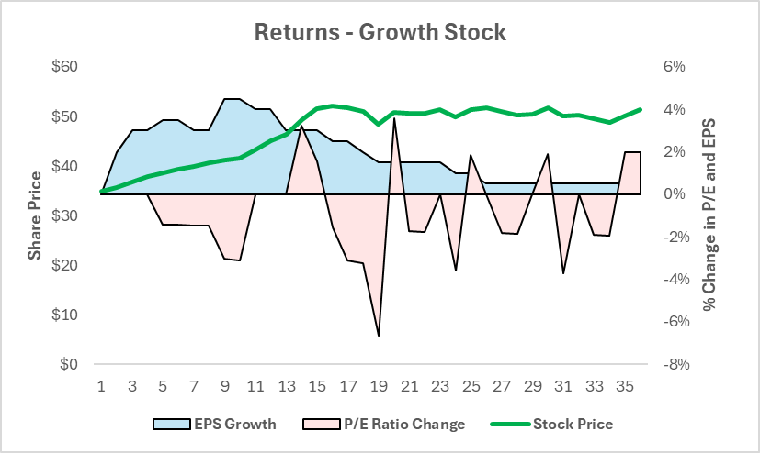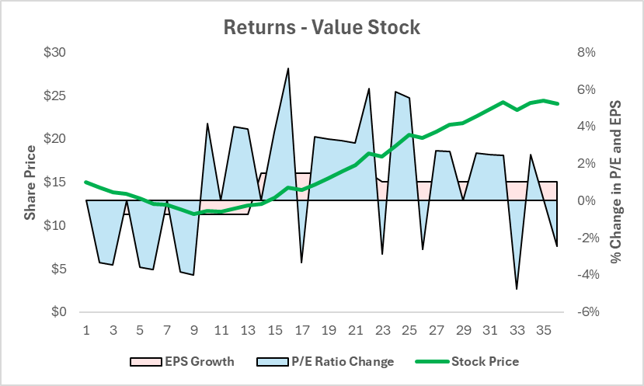
So despite the growth stock having 97% earnings growth compared to 20% for the value stock, the large repricing of risk through the P/E ratio multiple from updated investor expectations far outweighs the EPS growth’s contribution to returns, causing the value stock to outperform.
So, the goal is to decipher between stocks that have been beaten down because of irrational pessimism/cognitive biases and those that are simply poorly performing risky stocks. We want to use these cognitive biases and pessimism as buying opportunities, allowing us to pick up phenomenal companies at cheap prices while avoiding the truly risker stocks.

Why Don’t Many Institutional Investors Follow This Strategy?
Financial advisors, fund managers, and financial institutions all have an obvious incentive. Keep their jobs. They don’t keep their jobs if their investments don’t perform well. Every large fund manager is constantly compared to the market or a benchmark they’re measured against. If they underperform by 5% for one year, investors in the fund will see this and immediately pull their money out, asking why they’re invested in an energy stock they’ve never heard of when AI is the future. So, they are incentivized to mirror these benchmarks to avoid underperformance, regardless of the opportunities that exist.

Why Don’t More Retail Investors Follow This Strategy?
Now that we know why most fund managers don’t value invest (because they can’t deviate too far from market returns), why don’t more retail investors follow this strategy?
For one main reason: this strategy is simple, but very difficult.
It is extremely difficult to decipher between a value stock that still is a sound company and has just gotten irrationally beaten down from one that is truly risky. This requires a great understanding of financial statements, business, economics, and different industries, and requires a lot of time spent researching these topics.
It is also challenging because of these cognitive biases. It takes a lot of objective reasoning with a very emotional thing: money.
We associate what has been a good investment with what will be a good investment. So, it is very hard to look at a stock that has declined 40% in the last 2 years and still buy it. It’s even harder to keep trusting the process when you buy it and it goes down another 20%, and then to not sell it when you’re finally back at break even. But this is exactly what it takes. Seeing underperformance of 20% one year and still trusting the process. After all, if you want to beat the market you have to deviate from the market.
Also, the media has an incentive to make the news as entertaining as possible, so they are less likely to tell you to go buy a boring manufacturing company because it’s currently undervalued. Thus, media reports how Nvidia is projected to do tons of sales over the next couple years and that the stock is going to explode, gaining more views than simply preaching the value in buying a stable company and holding.

So What Will Future Blogs Be About?
Mainly on value investing, and different opportunities I see in certain stocks that I am personally invested in. I will never give a stock pick that I do not personally invest in, and I will publish the returns and holdings of my portfolio periodically. I will be fully transparent and use my portfolio as a proving ground for value investing and educate my readers on the “why” behind my investments every time.
However, value investing does not require too much active management. It is a long-term buy and hold strategy mainly, so there will be plenty of downtime to write about other topics across economics, finance, business, and psychology (within finance). Some blogs may be a little bit of a tangent into some more interesting or recent topics.
However, every blog post has the same main goal. Educate my readers about financial markets and how to successfully value invest to diversify, lower risk, and still earn great returns.

Mutual Funds and ETFs That Value Invest
Given this blog will be mainly about singular value stock picks and tracking my own portfolio, I would like to give you an out if you believe in this strategy but do not want to manage investments and spend the time yourself.
Below are some mutual funds and ETFs that follow a value investing strategy or a similar methodology. You can find out more about their returns, fees, and methodologies on their website or on Morningstar.com.
- FullerThaler Behavioral Small-Cap Equity Fund (FTHSX)
- Vanguard Value ETF (VTV)
- iShares Russell 1000 Value ETF (IWD)
- Schwab U.S. Large-Cap Value ETF (SCHV)
- Avantis U.S. Large Cap Value ETF (AVLV)
- Dimensional US Targeted Value ETF (DFAT)
- Dodge & Cox Stock Fund (DODGX)
- Oakmark Fund (OAKMX)
- Tweedy, Browne Global Value Fund (TBGVX)
- Fidelity Value Fund (FDVLX)

https://www.berkshirehathaway.com/letters/2024ltr.pdf
https://www.federalreserve.gov/releases/z1/20250911/z1.pdf

